Running Instructions and Project Details

**Section A: Basic Details**

|  |  |
| --- | --- |
| Project | CIMB_API |
| API Base URI | <https://developer.todoist.com/rest/v1/> |
| Test Scenarios | 1. Create a New Project and verify the project created successfully 2. Create a New Task under the project and verify it’s created successfully 3. Update the task content |
| Automation Framework & Document created by | Vishwanatha Thimmanna Hebbar |
| Programming Language | Java |
| Tool used | RestAssured API |
| Framework used | TestNG |
| Design Pattern | Hybrid Frame including Data driven Approach |
| Other Features | * Supports parallel execution * Generates Extent report along with TestNG report * Generates logs   **Notes:**   1. Given token (Bearer f3b085e6fa8b41f202e9be0173367cc8f6cc1817) not authorized for HTTP POST requests hence test cases are failed with response code 401(UnAuthorized) .   Cross verified POST request through postman , still faced 401 unauthorized(Refer to snapshot in section D)   1. Above token works fine for HTTP GET requests 2. Test cases can be executed, only the GET method , I have included is successful now with status code 200 3. All test cases are expected to PASS , if we update “config.properties” file under “Config” folder with token which has authority for HTTP POST requests. 4. It follows data driven approach, Hence we need to update correct test in file “APITestData.xlsx” under “TestData” folder.     Test data to be updated in corresponding tab:  Tab: CreateNewProject -> “name” column can be any sample value  Tab: CreateNewTask -> “content” column can be any sample value  **-> “project_id” column should contain valid project id from data base, so that new task will be created successfully for given project id.**  Tab: UpdateTaskContent -> “due_string” column can be any sample value  **-> “project_id” column should contain valid project id from data base, so that task will be updated for the given project id.** |
| **GitHub Repository URL** | <https://github.com/vthebbar/CIMB_MY.git> |
| **Test Reports Folders** | **TestNG Report : test-output-> index.html and emailable-report.html**  **Extent Report : Reports-> ExecutionReport_dd-MM-yyyy hh-mm-ss.html** |

**Section B : Pull code from GitHub repository**

Pre-requisite : GIT Bash software is installed in PC and GIT HUB account

Step1 :Create folder in your pc

Step 2: Open GIT Bash (Right click inside the folder and click on : Git Bash Here

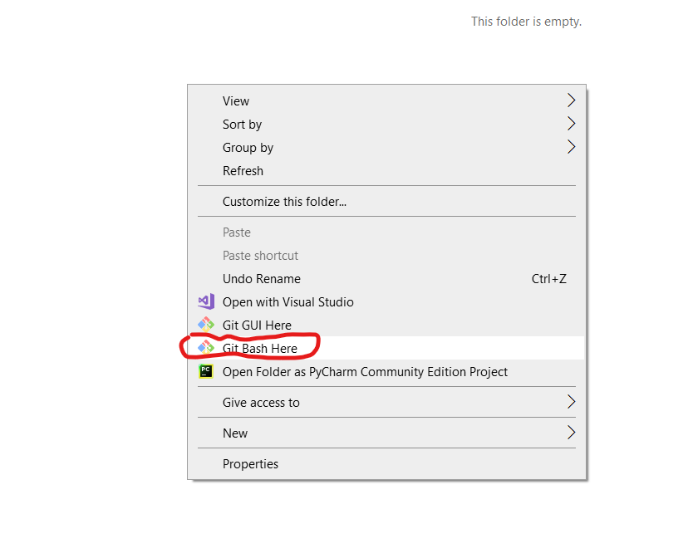

Step 3:

Run command > **git init**



Step 4:

Run command > **git pull https://github.com/vthebbar/CIMB_MY.git**

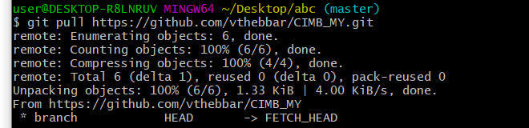

After step 4, project will be downloaded into the folder.

**Section C : How to Run the project on Standalone computer**

Approach 1: Using “Run.bat” file in project home directory ( Preferred & easy Approach )

|  |
| --- |
| ->Double click on “Run.bat” file shown below and wait till execution completes. |

**Approach 2: Using windows command prompt**

|  |
| --- |
| Step 1:  Open windows command prompt and navigate to project home directory    Step 2:  Run command : **mvn clean install** |

Approach 3: Run using “pom.xml” file

|  |
| --- |
| Step 1: Import the project in eclipse IDE    Step 2: Right click on: pom.xml -> select : Run as -> click on: Maven Test |

Approach 4: Run using “testng.xml” file

Step 1: Import project in eclipse IDE

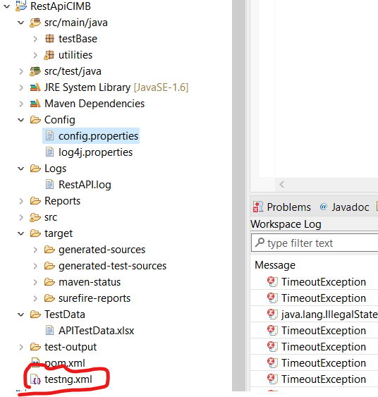

Step 2: Right click on : **testng.xml** file -> Select : Run as: -> Click on : TestNG Suite

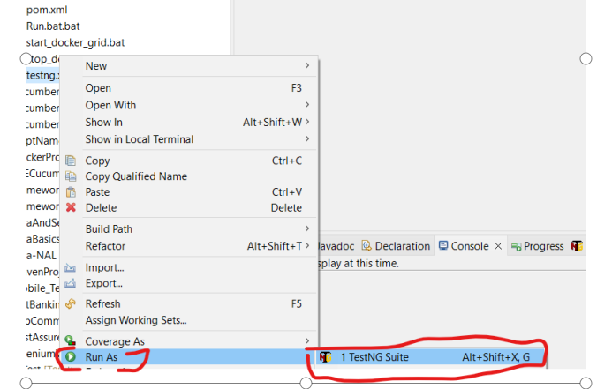

…

Note 2:

To view report in detail: Extent Report menu options:

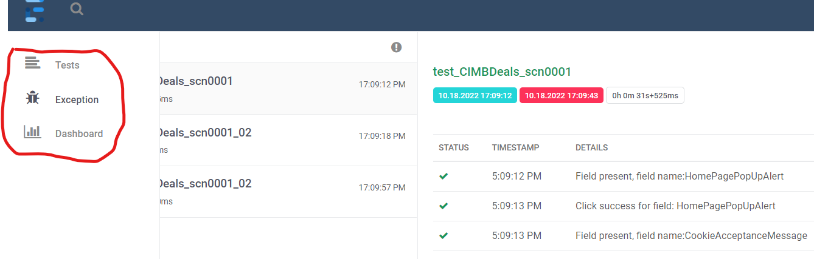

**Section D: API HTTP POST request authorization errors**

With Respect to API automation there is authorization issue with respect to HTTP POST requests which means, task and project creation fails.  Below is the error snapshot.

Test cases will run successfully with Fail result.

The Given bearer token works for HTTP GET requests but fails for HTTP POST requests.

HTTP POST Request - Not authorized

Using Bearer Token - f3b085e6fa8b41f202e9be0173367cc8f6cc1817

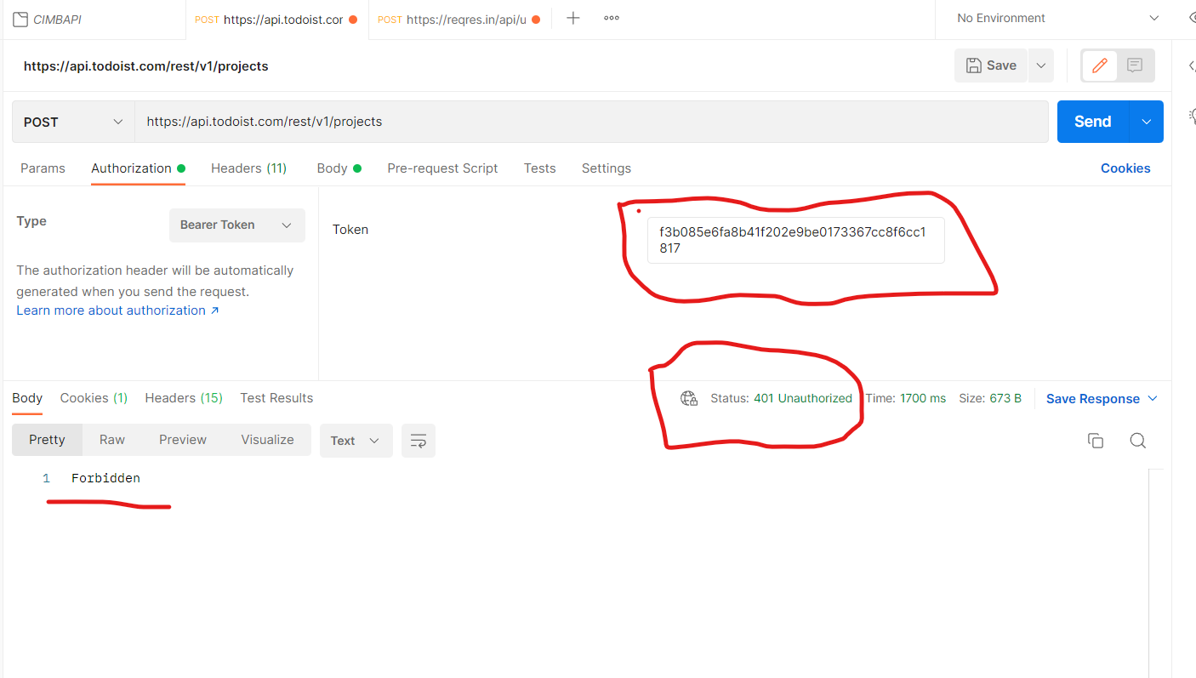

Automation code also shows same error and unable to create project.

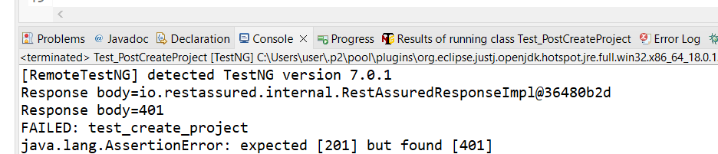

Using User ID and password (Basic authentication also not working)

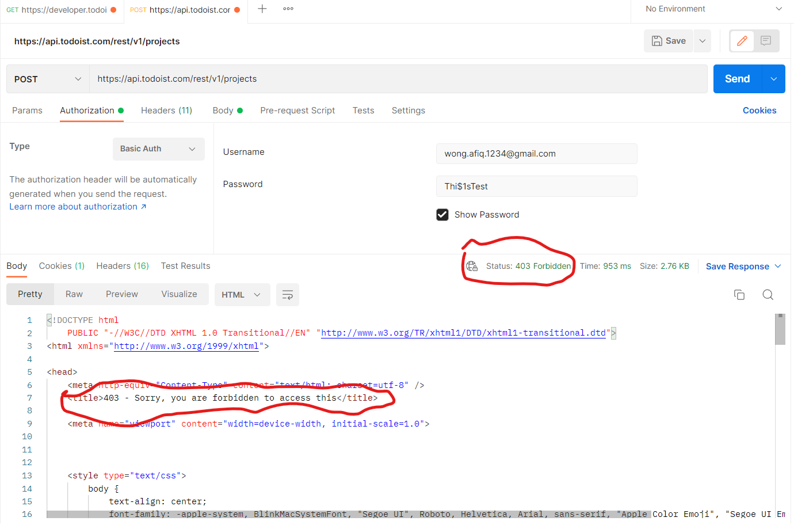

**HTTP GET request is ok. Using Bearer Token - f3b085e6fa8b41f202e9be0173367cc8f6cc1817**

